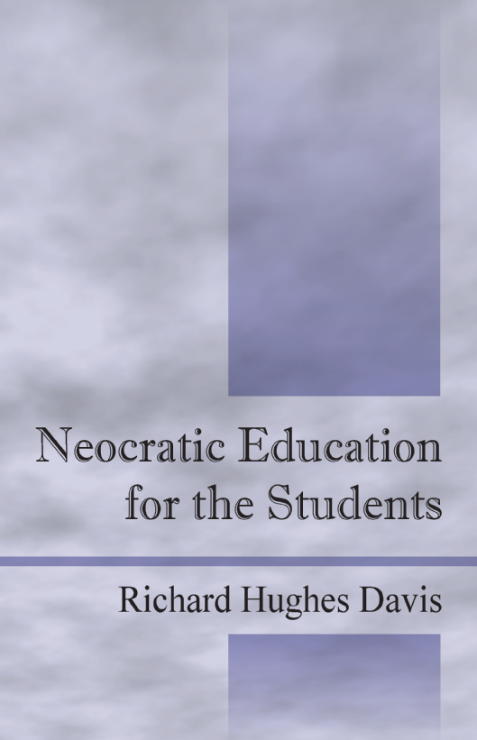
NEOCRATIC EDUCATION
FOR THE STUDENTS

HURRICANE KATRINA MAY BE
OUR BEST TEACHER TODAY

Schools can help students achieve
more meaningful socialization
by modifying their thinking

Richard Hughes Davis, M. Ed.

Foreword by:
DR. WRIGHT L. LASSITER, JR.
President of El Centro College, Dallas County Community College


From Storming Rains to Sunshine Series

From Storming Rains to Sunshine Series is a collection of writings by Richard H. Davis, inspired by Hurricane Katrina. These pieces focus on how people – with adequate encouragement and empowerment – through untapped resilience, can rise from the severest “storms of life” and realize the majestic beauty and restorative power of their God-given existence through faith and spiritual obedience to God.

NEOCRATIC EDUCATION
FOR THE STUDENTS

Educators can learn from Hurricane Katrina. It is time to change the American system of education. This is a clarion call for educational "neocrats" to catalyze this business of rescuing students from societal storms.

Bureaucratic “red tape” has too frequently impeded organizational effectiveness. America and the world saw how inadequately local, state, and federal bureaucratic agencies performed to rescue Hurricane Katrina evacuees. However, more shameful is the fact that millions of Americans across the nation are impoverished and ill-equipped to help themselves in the first place.

This book draws philosophical comparisons between the hurricane victims and American students and suggests that too many students are not prepared to rescue themselves from the current “storms” in their lives. The schools must lead the way to help students hope for a good present and a better future. Unfortunately, the school bureaucracy is also restricted by red tape. The family, religious, political, economic, and educational institutions are compelled to collaborate in order to create a new philosophy and a new system that is designed for the students and, in part, by the students.

Admittedly, this work does not offer all of the solutions. More will need to be done to define, develop, and implement Neocratic FORCE©, Principles and Practices of Neocratic Education, The Anatomy of the Educational Neocrat, and The Cadence of the Neocrat. Educators must take a fresh, non-defensive look at their organizational beliefs and bureaucratic strategies and must exercise freedom to demand greater effectiveness. New thinking for a new effect is critical. Now is the time.

Neocratic Education for the Students
All Rights Reserved
Copyright © 2005 Richard Hughes Davis

Outskirts Press
http://www.outskirtspress.com

Davis Academic Project
http://www.davisacademicproject.com

ISBN-10: 1-59800-192-2
ISBN-13: 978-1-59800-192-X

Outskirts Press and the “OP” logo are trademarks belonging to
Outskirts Press, Inc.

To order this book, visit www.outskirtspress.com/neocraticeducationdavis

Also visit www.neocraticeducation.com

